https://doi.org/10.48417/technolang.2021.04
Research article

Title
First Author¹[0000-1111-2222-3333] and Second Author²() [0000-1111-2222-3333]
¹ Peter the Great St.Petersburg Polytechnic University, St.Petersburg, Polytechnicheskaya, 29, 195251, Russia
² Darmstadt Technical University, Karolinenpl. 5, Darmstadt, 64289, Germany,
name@spbstu.ru
Abstract
Abstract should be between 150 and 300 words. It should reflect the essence of what your research is about. As usual informative abstracts also have key parts in common. Each of these parts might consist of 1–2 sentences. The parts include: background, aim or purpose of research, method used, findings/results and conclusions. The abstracts provide accurate data on the contents of the work, especially on the results section. Informative abstracts are short scientific productions, since they follow the IMRaD structure and can in fact replace the whole text, because readers extract from these the most valuable information and in many instances it is not necessary to read the complete text. Front size-10
Keywords: First Keyword, Second Keyword, Third Keyword (5-7)
Acknowledgment (if any)

Citation: Surname, A., & Surname, V. (2022). Title. Technology and Language, 3(1), X-X. https://doi.org/10.48417/technolang.2022.04.03

This work is licensed under a Creative Commons Attribution-NonCommercial 4.0 International License

This work is licensed under a Creative Commons Attribution-NonCommercial 4.0 International License
Title

INTRODUCTION
Article text in full formatted as follows: equal width; paragraph-1 cm; font-Times New Roman; font size-12.

TITLE
The text of the article should be divided into semantic parts. Various headings and subheading of the study can be decided by authors. Your headings may be different depending on nature of study.
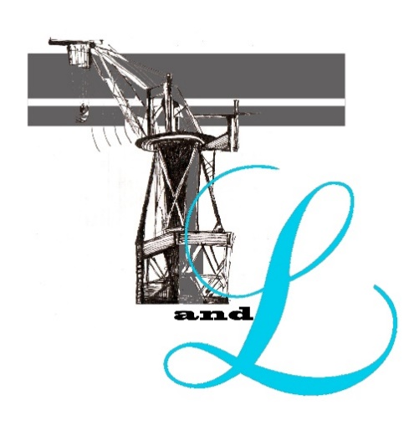
Figure 1. Title

TITLE
Table 1. Title

REFERENCES
References must be organized according to 7th APA standards

Linder, C. (2020, Jun 25) This AI Robot Just Nabbed the Lead Role in a Sci-Fi Movie. Popular mechaniks. https://www.popularmechanics.com/technology/robots/a32968811/artificial-intelligence-robot-movie-star-erica/
Lo Bianco, J., & Aronin, L. (2020). Dominant Language Constellations. Springer International Publishing. https://doi.org/10.1007/978-3-030-52336-7
Nordmann, A. (2020). The Grammar of Things. Technology and Language, 1(1), 85–90. https://doi.org/https://doi.org/10.48417/technolang.2020.01.18

СВЕДЕНИЯ ОБ АВТОРАХ / THE AUTHORS
ФИО, email, ORCID | Name, email, ORCID

Статья поступила  одобрена после рецензирования  принята к публикации | Received: 14 June 2021 /  Revised: 18 August 2021  Accepted: 28 September 2021

